SUMMERVILLE CREDIT UNION · CONSOLIDATED MEMBER GUIDE · CSUM-02 of 30
Dashboard & Activities Since Last Login

Module: nFinia Digital Banking > Dashboard
Sources: Summerville Reports Series A (36 docs) + Series B (25 docs) | Features: nFinia Documentation Features Spreadsheet
01 PRODUCT SUMMARY

The Dashboard — Banking Summary is the first screen a Summerville Credit Union member encounters after completing multi-factor authentication. It is the command centre of the nFinia digital banking experience: a single, consolidated view presenting the member's complete financial picture — all account balances, recent transactions, pending items, and primary action shortcuts — without requiring navigation to individual account pages.
Quick-action tiles on the Dashboard provide one-tap access to the most common member tasks: initiating a transfer, making a payment, depositing a check, or viewing recent activity. The Dashboard is intentionally designed as a zero-friction summary, enabling members to assess their financial position and initiate the most common banking actions directly from one screen.
The Activities Since Last Login feature (accessible via More > Recent Activities) presents a real-time audit log of all account events that occurred since the member's previous session, providing an instant security check and activity summary.

At a Glance

Attribute | Detail
Module | nFinia Dashboard (post-login landing screen)
Accounts Shown | All accounts under the active membership
Quick Actions | Transfer, Pay, Deposit, Alerts, Move Money
Activities Log | Events since last login (Recent Activities / More menu)
Refresh | Pull-to-refresh or auto-refresh on session open
Related Reports | CSUM-01 (Login), CSUM-03 (Account Overview), CSUM-31 (Recent Activities)

02 KEY USE CASES

Use Case | Who Uses It | What They Do | Business Value
Morning Balance Check | Member starting their day | Open app, view Dashboard for all account balances | Single-screen financial overview without navigating to each account
Quick Transfer | Member moving funds between accounts | Tap Transfer tile on Dashboard, complete transfer | Fastest path to internal transfer without full navigation
Post-Login Security Review | Security-conscious member | View Activities Since Last Login for unexpected events | Instant detection of unauthorized account activity
Sneak Peek Balance | Member wanting balance without full login | Enable Sneak Peek to view balance before authentication | Quick balance check without full credential entry

03 STEP-BY-STEP GUIDE

Navigation: Dashboard is the landing screen immediately after successful login. No additional navigation required.

Step 1 — Start from Dashboard
The member begins at the Dashboard after logging in. The Dashboard displays all account balances, upcoming payments, quick-action tiles, and the top navigation bar with links to Accounts, Move Money, and More.
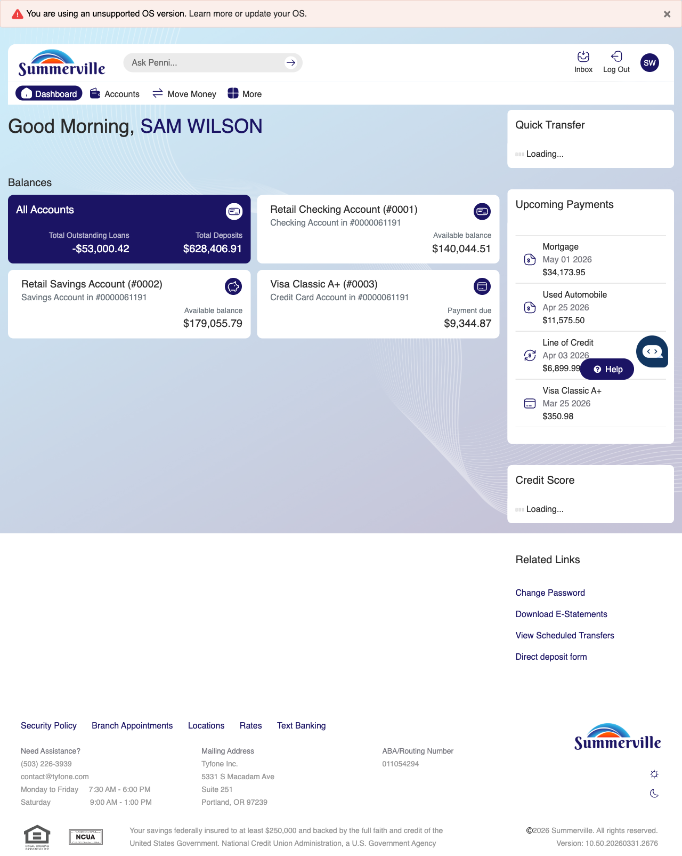
Step 1: Start from Dashboard

Step 2 — Navigate to Move Money Hub
The member clicks ‘Move Money’ in the top navigation bar. The Move Money Hub displays all payment and transfer options as tiles including Pay Bills, Quick Pay, Zelle Payment, Internal Transfers, Other Members, Same-Day Transfers, Send Instantly, Manage Recipients, Add Recipient, Transaction History, Scheduled Transfers, and P2P Transfer.
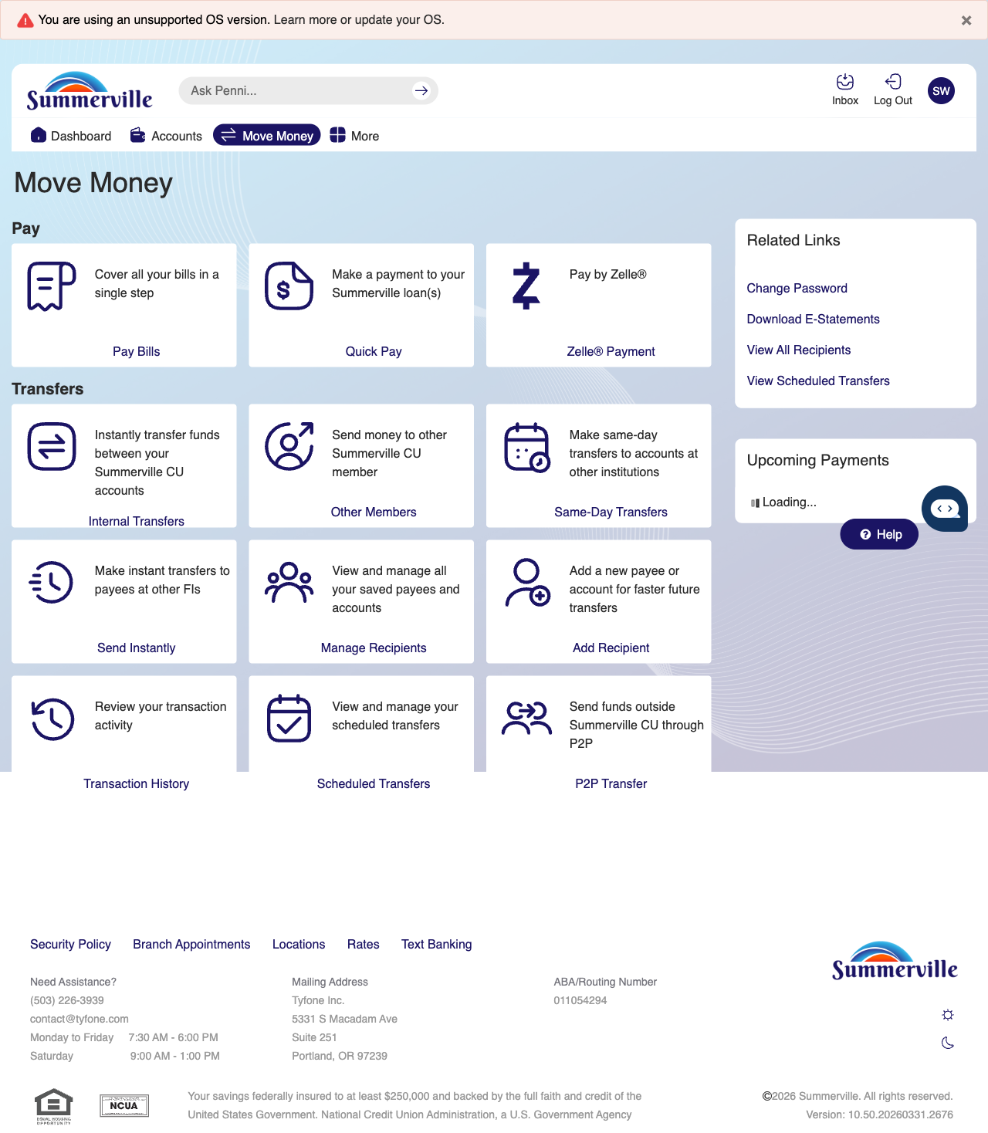
Step 2: Move Money Hub

Step 3 — View the Dashboard
The main Dashboard is displayed after login, showing multiple account cards with current balances, an upcoming payments sidebar on the right, and quick transfer options available in the right panel.

Step 3: View the Dashboard

Step 4 — Use Quick Transfer from Dashboard
The Accounts page is shown with a detailed list of multiple checking and savings accounts. Each account displays the account name, masked number, and current balance with available action buttons.
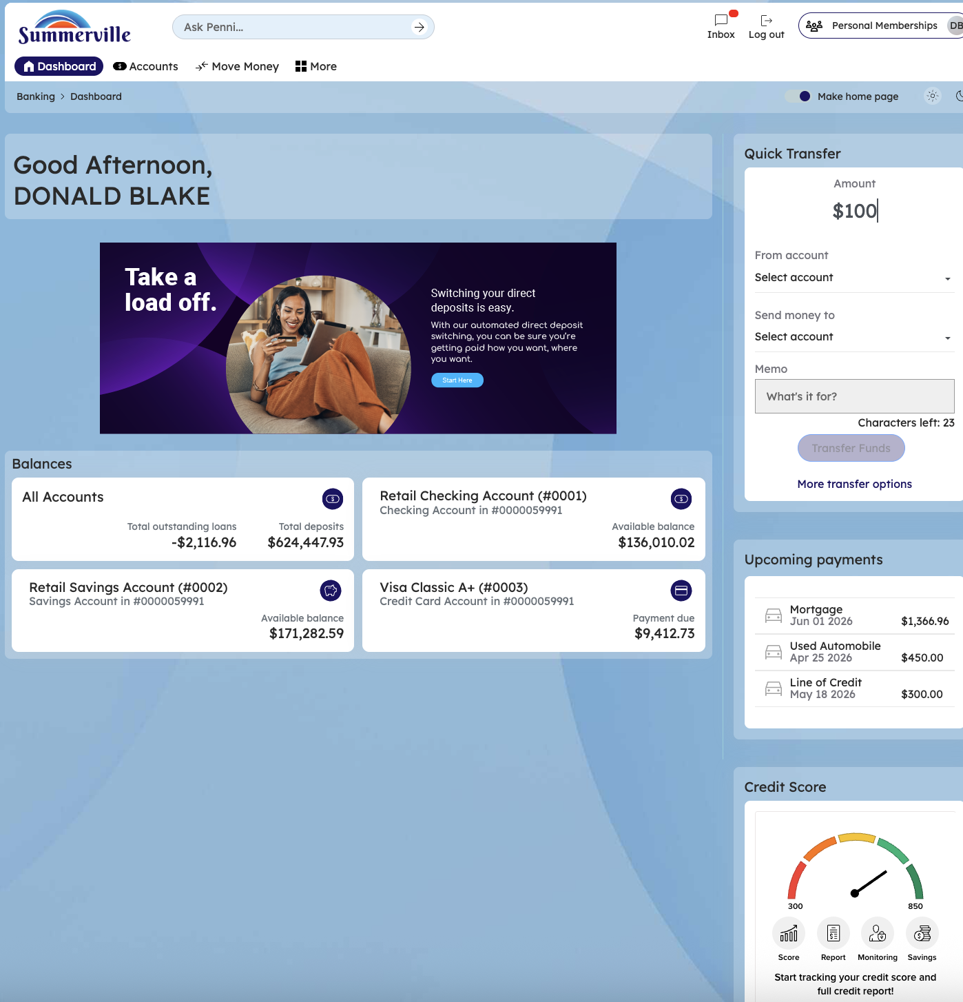
Step 4: Use Quick Transfer from Dashboard

Step 5 — Fill Quick Transfer Details
The accounts list view is displayed in a scrollable format showing multiple account options with their account types and current balances for selection.
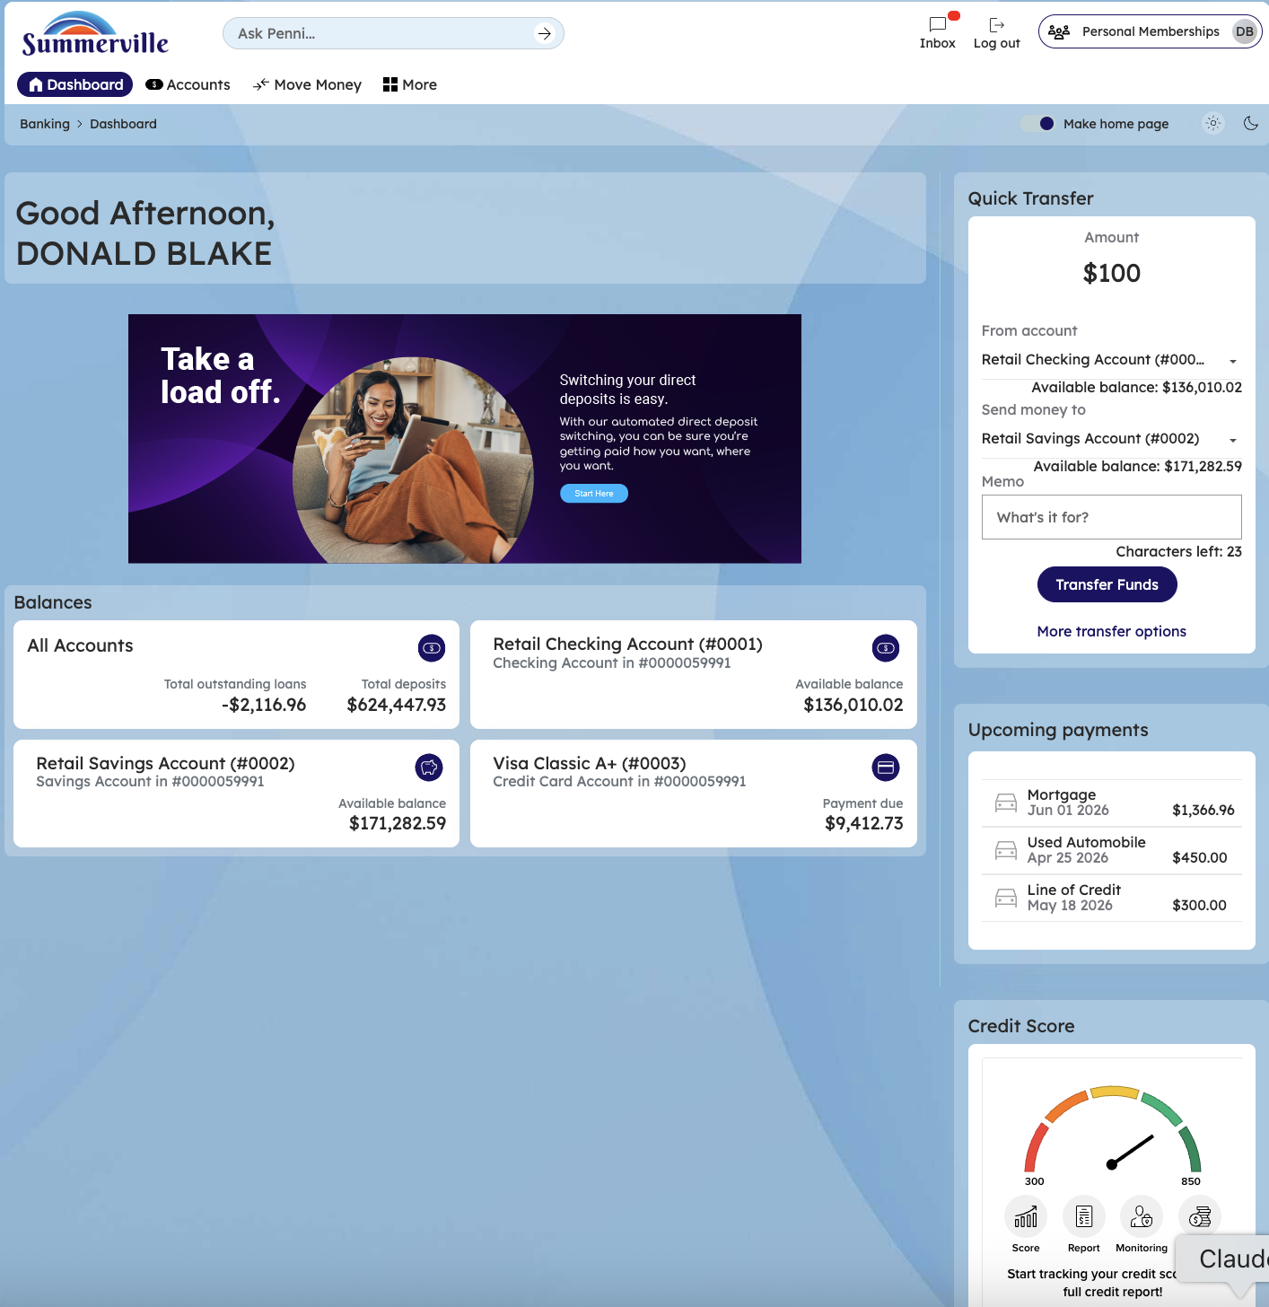
Step 5: Fill Quick Transfer Details

Step 6 — Enter Transfer Amount
A full Accounts page is shown displaying all account types — checking, savings, credit cards, and loans — organized by category with their respective balances and transaction history links.

Step 6: Enter Transfer Amount

Step 7 — Confirm Quick Transfer
The account overview page displays all account types organized by category. Recent transactions and related action buttons are visible for each account entry.
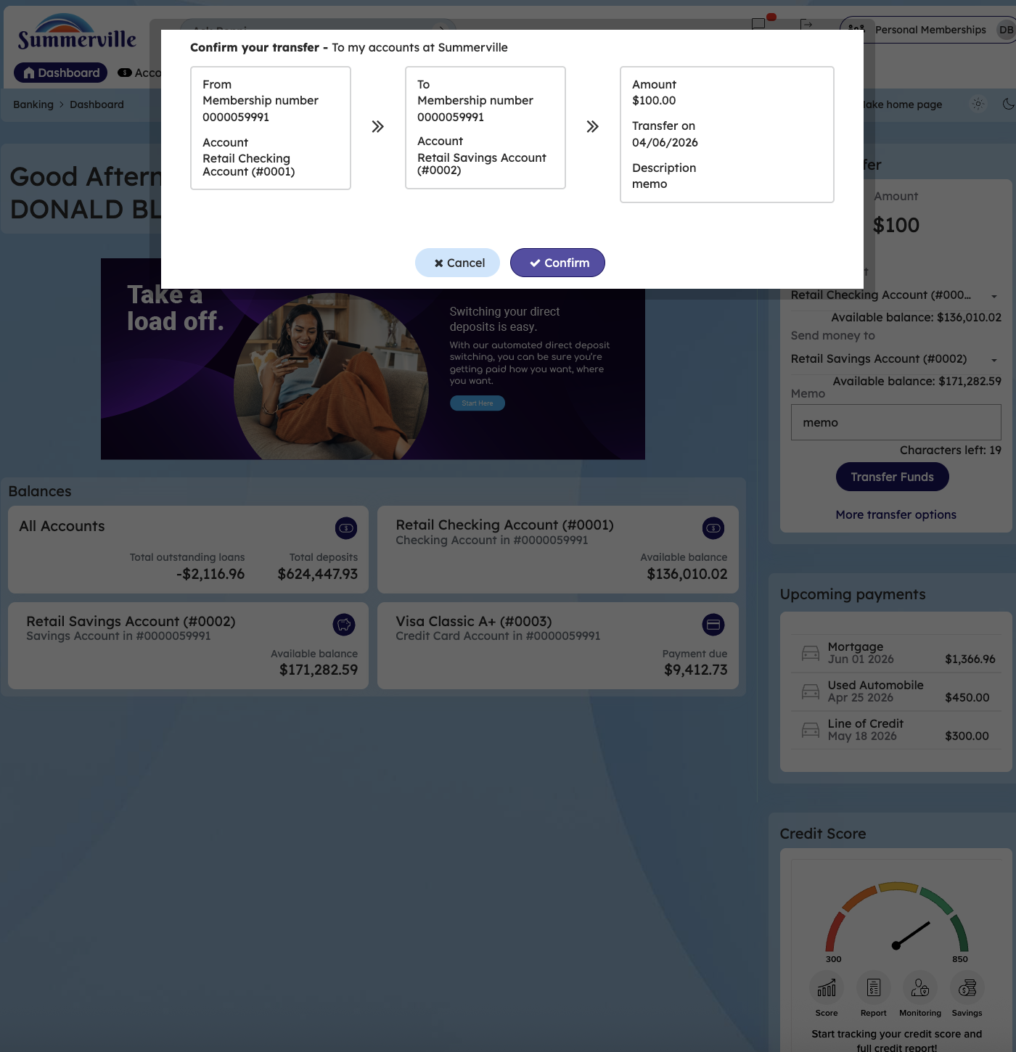
Step 7: Confirm Quick Transfer

Step 8 — Log Off Securely
A logout confirmation modal is displayed over the accounts page interface. The modal prompts the member to confirm they want to end their session before logging out.
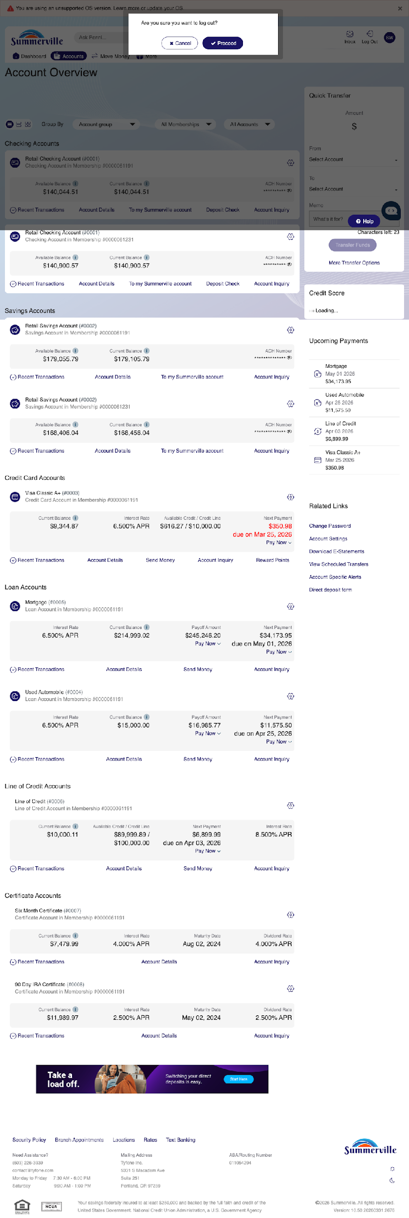
Step 8: Log Off Securely

